H1
GROUP 51
João Moniz nº 83480
Liana Baghdasaryan nº 104708

Work Distribution
Liana Baghdasaryan: q1
João Moniz: q2 and q3

Question 1:
1.1
a) b)
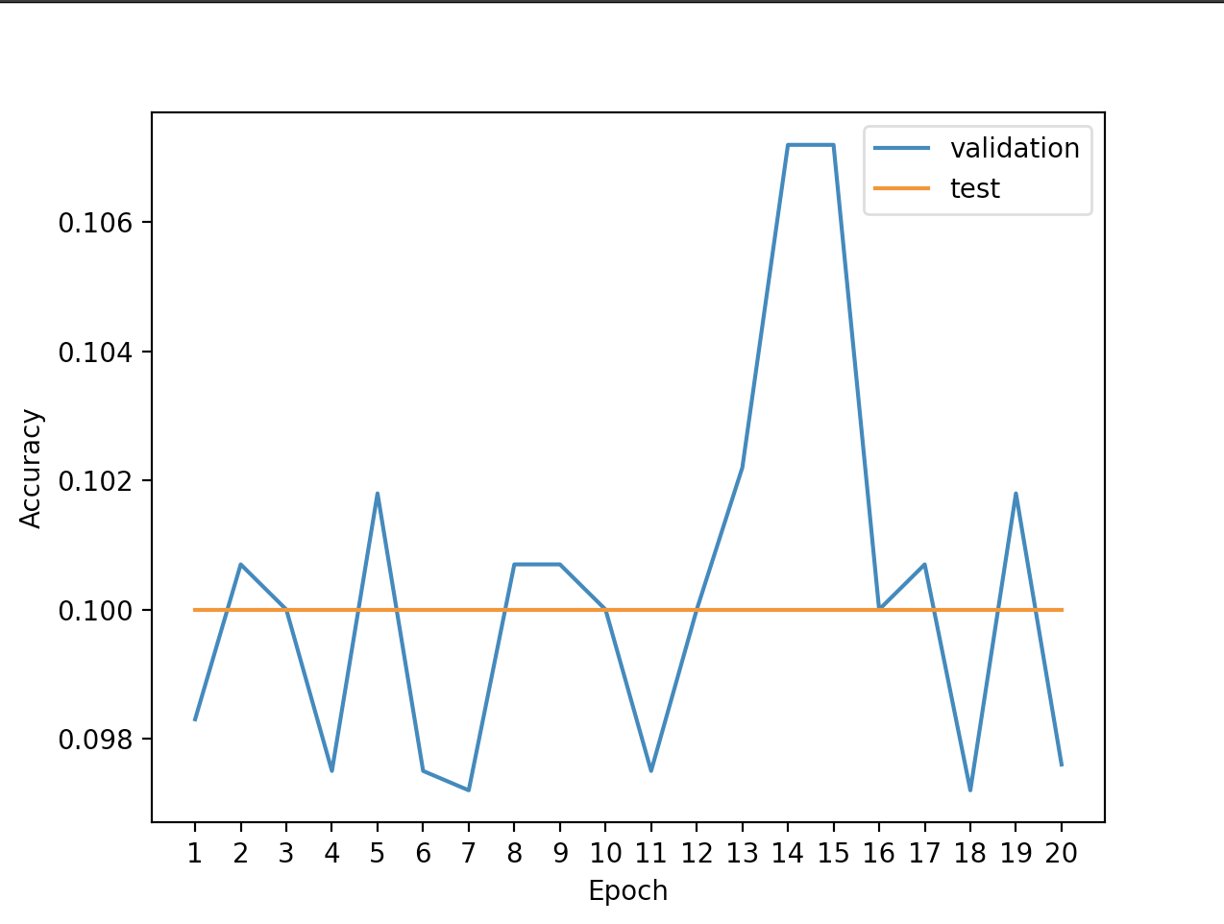
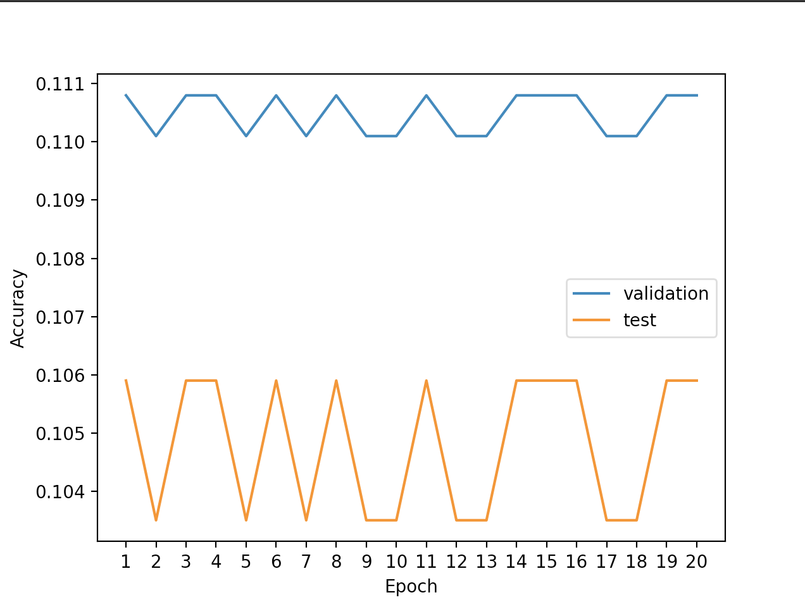

1.2.
b)
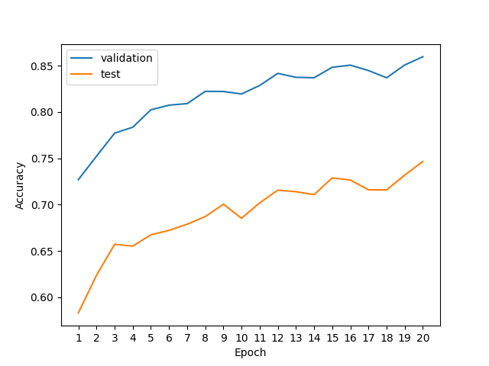

Question 2:
2.1:
Learning Rate 0.1 L.R. = 0.01
(F.T.A.=0.6151) (F.T.A.=0,6806)
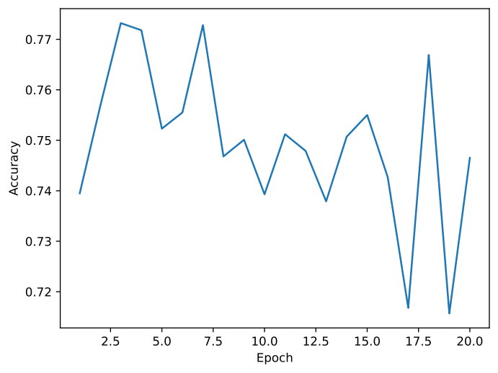
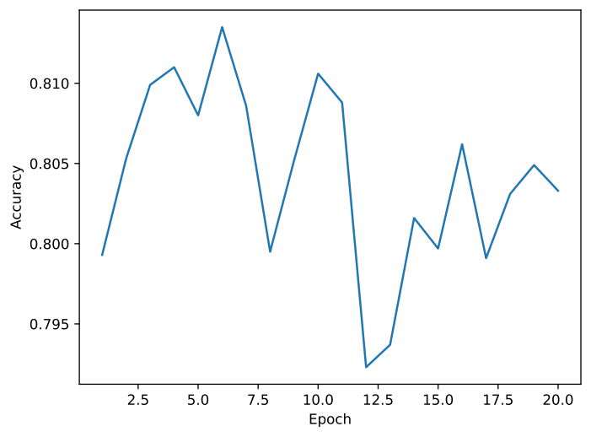

L.R.=0.001
(Final Validation Accuracy 0,7019)
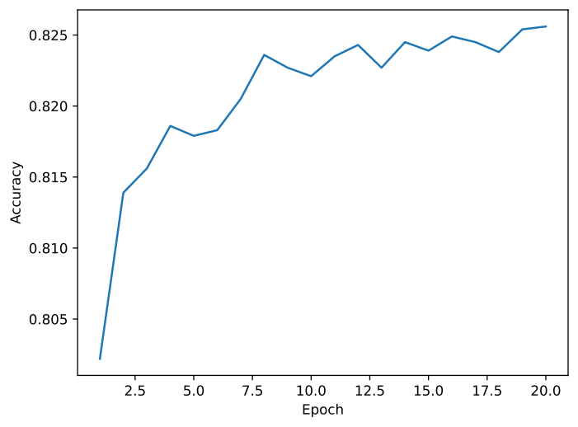

Best learning rate result was 0.001 with 0,7019 F.V.A..

2.2:
best
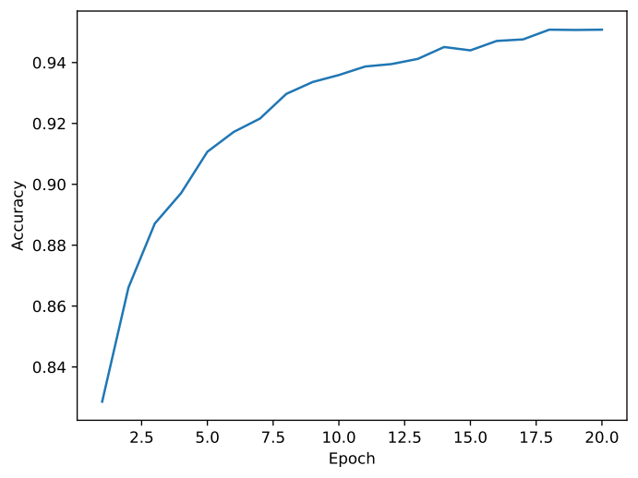
number of epoch = default
learning rate = default
hidden layer size = 200
drop out = default
batch size = default
activation = default
optimizer = default

F.V.A =0,8819

2.3:

nº of hidden layers= 2 nº of hidden layers=3

F.V.A.= 0,8815 F.V.A. = 0,8764

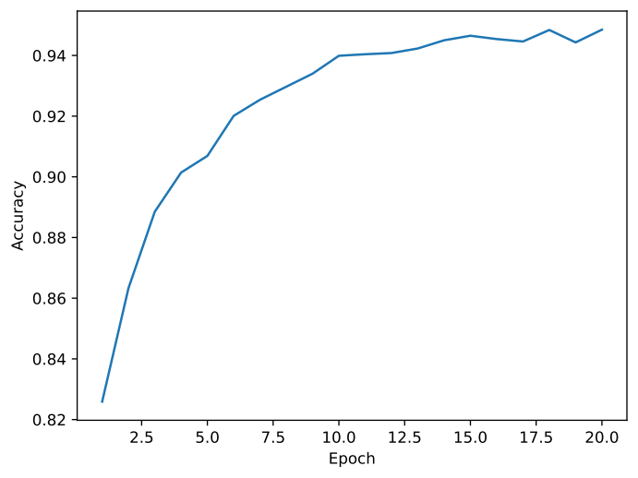
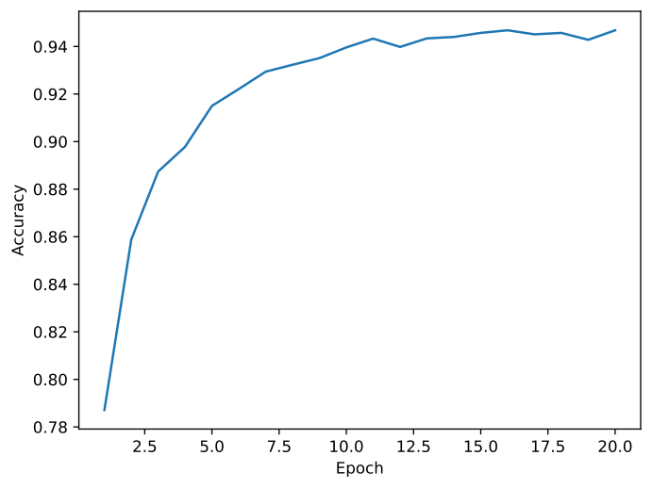

Best result is model with 2 hidden layers.

Question 3:
1 and 2

